Ekisa UK

Spring Newsletter 2023

**Dear Ekisa Supporter,**

Thanks to all your support we continue to help the important work of Ekisa in Uganda. Ekisa is dedicated to helping children with special needs in Uganda. The Ekisa focus is helping families to care, foster or adopt disabled children. Our support helps fund the ongoing construction of the Next Chapter: a new site for Ekisa and its Academy, providing education and therapy for around 50 disabled children who travel daily from home to the Academy.

The co-founder of Ekisa, Emily Henderson, and her daughter Debra, visited Ekisa at Easter….see below!

Now, some future dates for your diary for local events in Milton!!

**Ekisa Quiz**: this year we are teaming up with The White Horse for a Quiz on **Thursday September 28th**. Please come and join the fun and help us raise new funds.

**Ekisa Christmas Gift and Food Fair**: we are bringing back this popular event this year. The date is set for **Saturday November 11th** at All Saints Milton. If you would like to have a stall at the Fair please contact [info@ekisa.org.uk](mailto:info@ekisa.org.uk)

If you would like to help us run the Fair do get in touch! We do need some new volunteers! You can get in touch via [info@ekisa.org.uk](mailto:info@ekisa.org.uk) Thank you!

Ekisa UK has continued to send its regular, quarterly financial support to the team in Jinja; in 2022 this amounted to a total for the year of over £27,000. **A recent, huge donation should ensure an even bigger total for 2023.**

**This level of support is thanks to you, our generous supporters who make a regular donation to support Ekisa UK. I cannot stress enough how important this support continues to be.**

If you would like to set up a regular donation, please go to our ‘Donate’ webpage:

<https://www.ekisa.org.uk/giving> or contact our local treasurer by email at [treasurer@ekisa.org.uk#](mailto:treasurer@ekisa.org.uk#)

THANKS EVERYBODY!

**Roger Lemon, Chair, Ekisa UK, Charity Number 1167405**

**News from Uganda**

**EMILY AND DEBRA DIARY FROM THEIR EASTER VISIT TO EKISA**

Over Easter Debra and I were lucky enough to take a trip back to Uganda to visit Ekisa. We took lots of supplies with us including Debra’s old wheelchair and a folding hoist. Luckily we had the Ekisa school bus to pick us up which meant we were able to fit everything in.

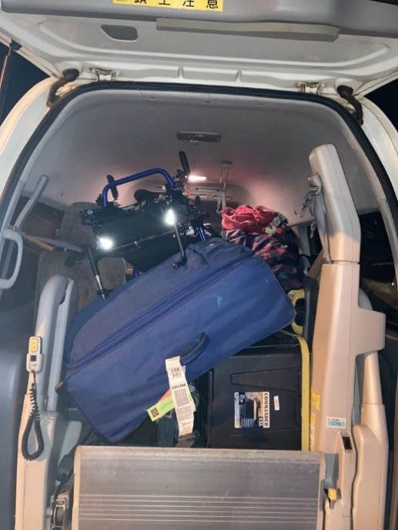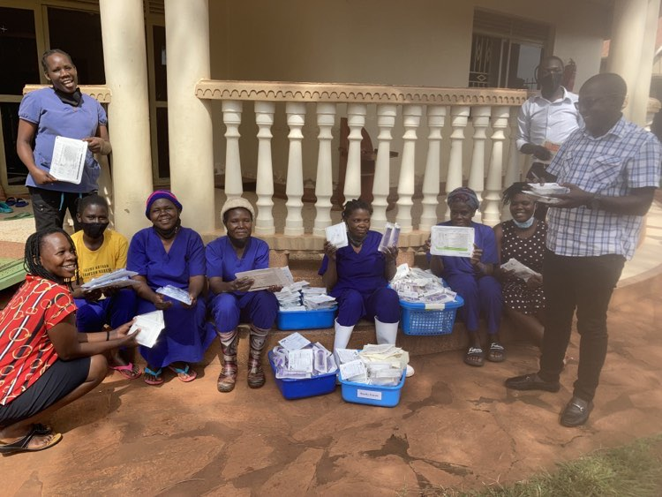

Even though our trip was short, just 11 days, it was a lovely chance to catch up with old friends and see all the amazing ways Ekisa has been growing over the last year. At the Academy they have added a new classroom which has allowed for more students to access special education. It was great to see so many new faces and see all the great work that is going into developing the curriculum. Debra also enjoyed showing some of her old teachers the work she has been doing at her new school in Cambridge.

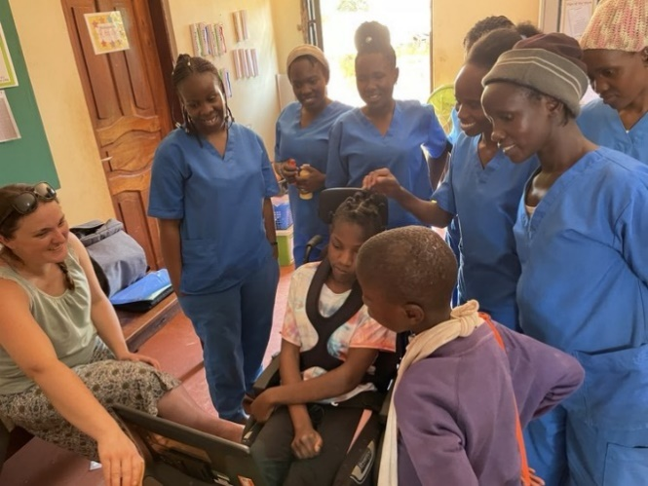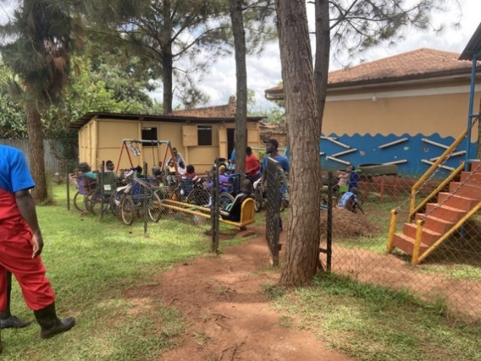

Some new children have joined the residential program and the social workers are all hard at work tracing their family backgrounds and making plans for long term care for each child. Some of the new children have quite complex medical needs, so the amazing nurses are always busy making sure the children are receiving the best possible care.

When we visited Uganda last year we were able to go and see the plot of land where Ekisa will build their new home as part of the Next Chapter. During that trip Debra was able to help make the first dig towards the foundations and it was exciting to think about all the possibilities for this piece of land. We heard that they have now finished building a well and a pump house and constructed a fence all around the property. I am looking forward to seeing what progress they will have made next time we visit.

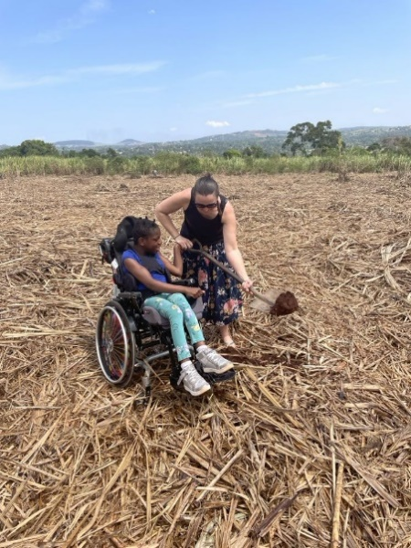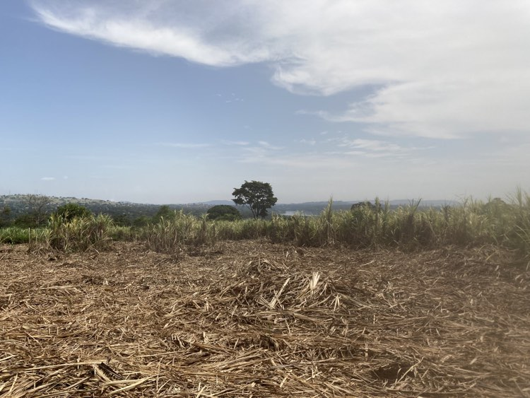

|  |  |  |  |  |  |  |
| --- | --- | --- | --- | --- | --- | --- |
| |  |  |  |  |  |  | | --- | --- | --- | --- | --- | --- | | |  | | --- | |  |  |  | | --- | | **DANIELS’S STORY**  To illustrate the great work that Ekisa is doing with disabled children in Uganda, I am attaching below the diary of Daniel, copied from the recent Ekisa Ministries newsletter |  |  |  | | --- | --- | | |  | | --- | |  | |  |  | | --- | | Image ImageImage    Daniel Keys is a young boy with disabilities who has recently found a loving family in Uganda willing to foster and potentially adopt him. This heartwarming tale is a testament to the incredible work being done by our dedicated team at Ekisa and the power of your support which makes it possible.    Daniel, a quiet little boy who loves cuddling and being called "Baby D," was under our care in our Transitional Home after being abandoned by his mother. Despite his challenges, he is incredibly perceptive and quickly recognizes the sound of his new foster mother, Jacqueline. According to Kose, a social worker at Ekisa, "he understands his foster mother's voice and differentiates it from someone else."    "I really was caught up with that heart of motherhood," says Jacqueline. "I really felt that I really need to take up this child because every child deserves a better home."    The journey to reintegrate Daniel into a family was a smooth and rewarding process for our team. "We did not find it hard to get a family for him," Kose explains. "The family was readily available. We educated the family on Daniel's needs, and we realized it was suitable for him." The support from the family, probation officers, and our team has been overwhelming, showing that love truly conquers all.    The most memorable moment for Kose and the Ekisa Ministries team was when Daniel was finally placed in his new home. "Happiness had covered each one's face. His mother made many phone calls, for she was so happy to see Daniel," Kose recalls with joy.    "Every child deserves a mother who loves her child," says Jacqueline. "[Even if] they cannot support themselves. As long as there's that heart and that person that can support, it does not need you to have everything to support a child. Even [with] the little you have, you can support. Our parents raised us up with the little they had, but we've grown up and we’ve become the best people in this world. So I believe that also Dan can become the best person, a better citizen of this world. And I really encourage all mothers out there. All parents out there. Don't mind about you being single. You can become a mother to someone. You can become a future to someone and a light to another person. And that person really will appreciate you, and you'll see God’s blessings when you do this."    This story is a shining example of the life-changing impact you are making on children with disabilities and their families. We're grateful for your support, which allows us to continue making a difference in the lives of these incredible children and families. Thank you for rewriting the story of disability with us!    Sincerely,  The Ekisa Ministries Team | | |